**Lesson08 Azure Backup service for Azure virtual**

**Notes:-**

**Components:-**

**A-Azure recovery Service Vault:-**

**1-with Azure backup service you can backup Azure VM**

**2-when the backup of Azure VM happen it will be stored in the Azure recovery services vault which hold the backup VM data**

**3-Azure recovery service vault should be in the same region of the Azure VM**

**4-Azure recovery service vault is enabled on trigger time so on each period time it will back up only the changed data between each backup and another to the Azure recovery service vault**

**B-Azure backup policy:-**

**which you can set the schedule time on the Azure recovery service vault so you can back up on specific period time such as each week or day and so on.**

**C-Recovery Point**

**Each time you backup VM it will create recovery point**

**D-Recovery Types**

**Each Recovery Points contains the 3 types of recoveries:-**

**A-File Recovery: which you can recovery specific file into the target VM you want**

**B-VM recovery: which you can duplicate new VM from the recovered VM**

**C-Disk recovery: which you can recover the Disk VM into the target VM**

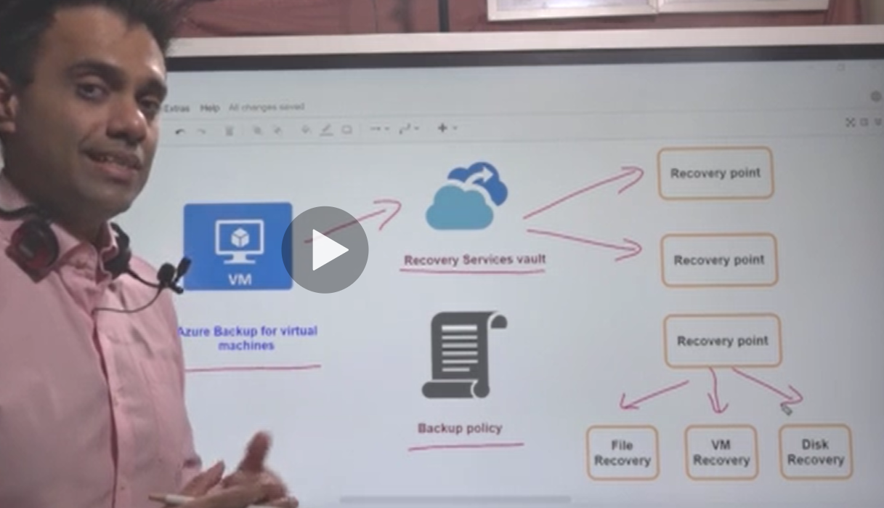

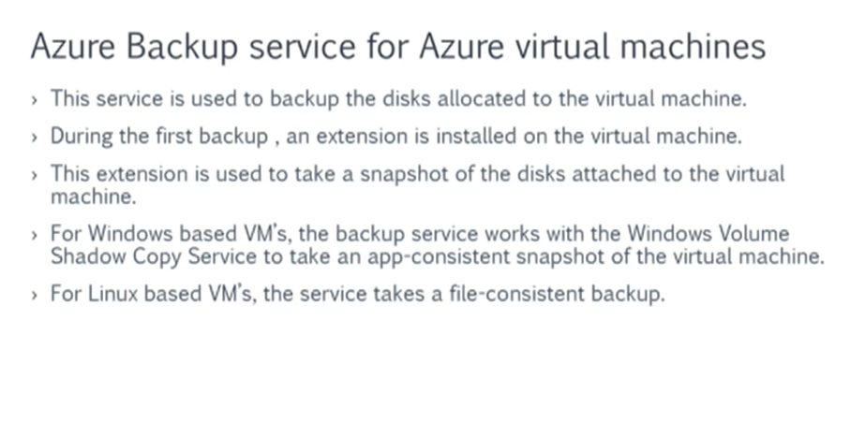

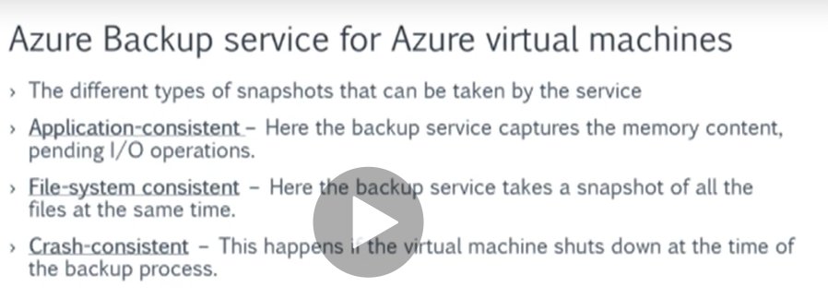

**Steps:-**

**1-we create Azure Recovery Service Vault which used to store the VM backup as recovery points**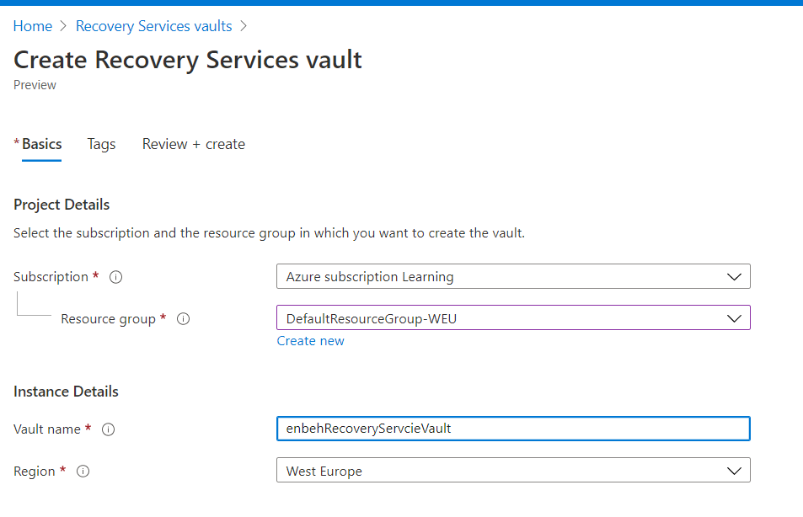

**2-on the Azure VM > backup option**

**(We enable backup for the Azure recovery vault service with the Azure VM as below)**

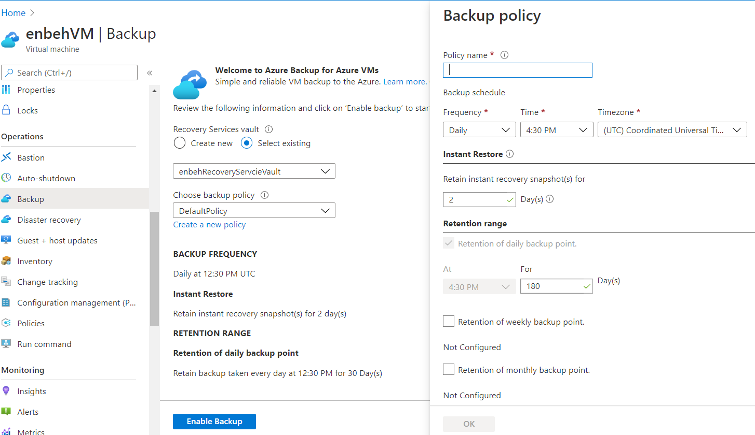

**(we also detect the time period which you will back up your VM at specific time plus the retention / keeping time which you can hold the recovery points on the Azure recovery vault service)**

**3-we see the backup history and you can click backup Now if you want to make currently restore point as below**

**(you can show all jobs from backup by click on View all jobs)**

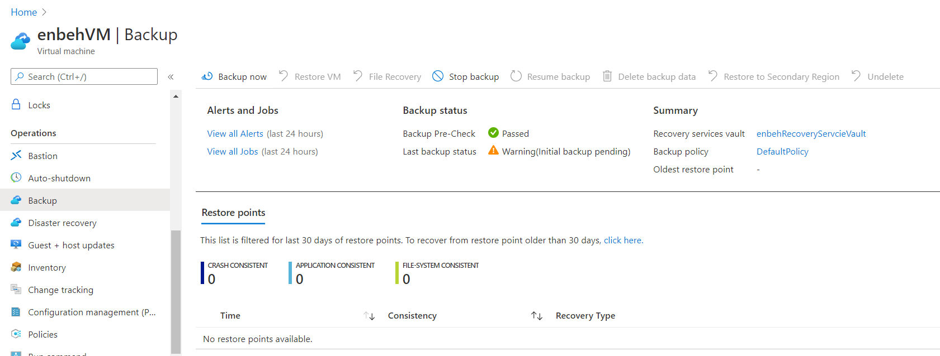

**(it will show two jobs one for generate VM snapshot and another for deliver to Azure Vault service)**

**4-we have to create Storage Account in order to use it in Staging Location in Create new VM from restored VM**

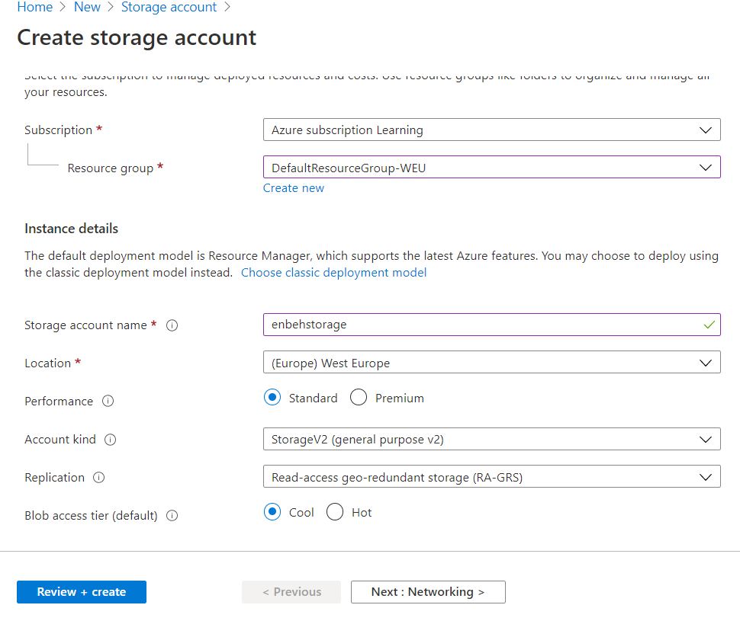

**5-click on restore and select the restore point, you have two options:**

**1-VM and Disk Recovery:-**

**(This options apply VM restore and disk restore only)**

**A-Create new**

**B-Replace existing**

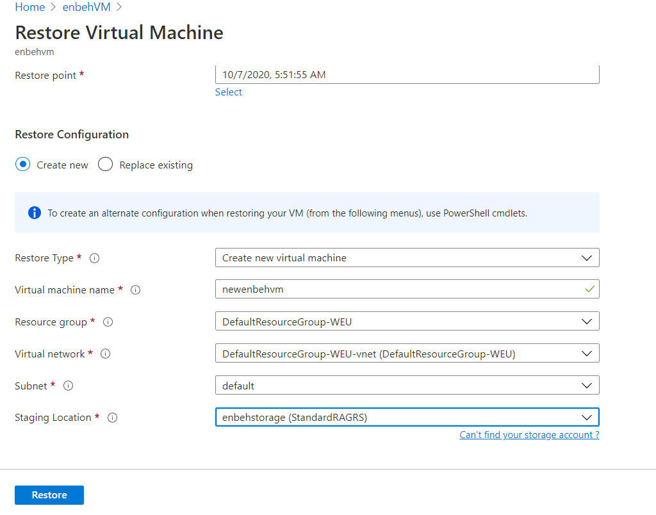

**2-File Recovery:-**

**Which can be used to recover files on the target VM**

